Practical No : 06

Title : Study and implement concept of Dynamic Web Pages using eclipse

A] WAP for creating simple servlet with JDBC

B] WAP for uploading and downloading files using servlet

Name: Suraj D Bele

Roll-No: MC16F14F049

**Index.html**

<!DOCTYPE html>

<html>

<head>

<meta charset=*"ISO-8859-1"*>

<title>Login page</title>

</head>

<body>

<form action=*"login"* method=*"post"*>

<table>

<tr>

<td><font face=*"verdana"* size=*"2px"*>Name:</font></td>

<td><input type=*"text"* name=*"userName"*></td>

</tr>

<tr>

<td><font face=*"verdana"* size=*"2px"*>Password:</font></td>

<td><input type=*"password"* name=*"userPassword"*></td>

</tr>

</table>

<input type=*"submit"* value=*"Login"*>

</form>

</body>

</html>

**LoginDemo.java**

**import**java.io.IOException;

**import**java.io.PrintWriter;

**import**javax.servlet.ServletException;

**import**javax.servlet.annotation.WebServlet;

**import**javax.servlet.http.HttpServlet;

**import**javax.servlet.http.HttpServletRequest;

**import**javax.servlet.http.HttpServletResponse;

@WebServlet("/LoginDemo")

**publicclass**LoginDemo**extends**HttpServlet {

**protectedvoid**doPost(HttpServletRequest request, HttpServletResponse response) **throws**ServletException, IOException {

// **TODO** Auto-generated method stub

PrintWriter pw=response.getWriter();

response.setContentType("text/html");

String user=request.getParameter("userName");

String pass=request.getParameter("userPassword");

**if**(user.equals("rohan")&&pass.equals("rohan"))

pw.println("Login Success...!");

**else**

pw.println("Login Failed...!");

pw.close();

}

}

**OUTPUT**:

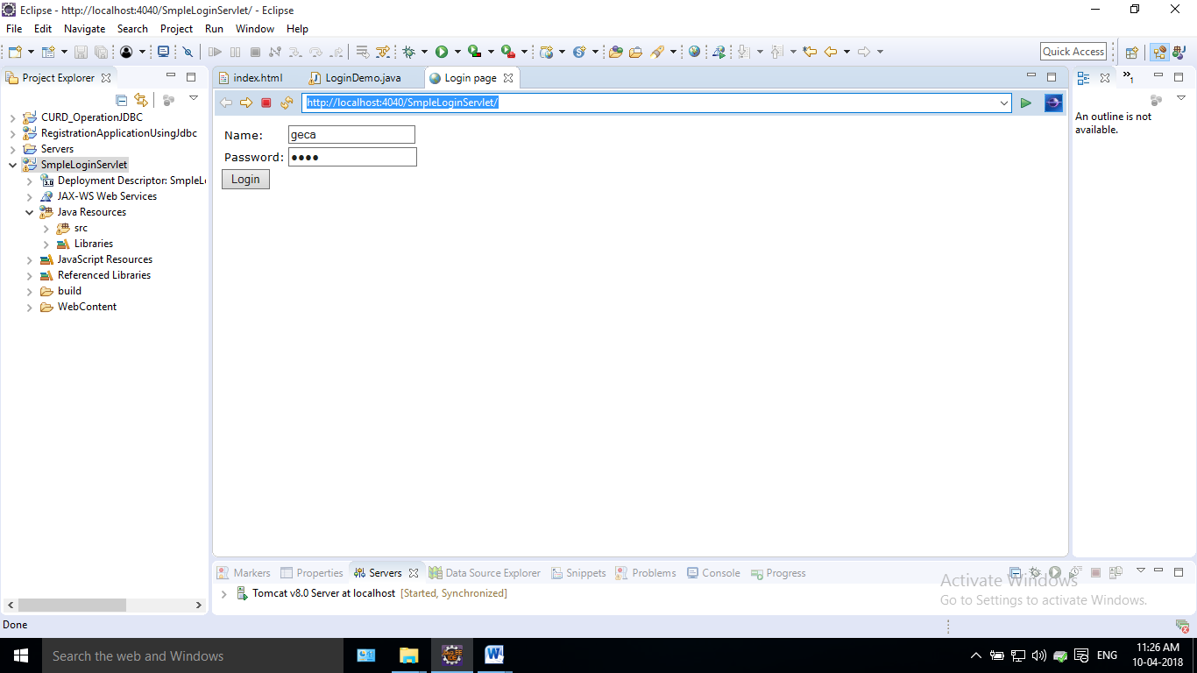

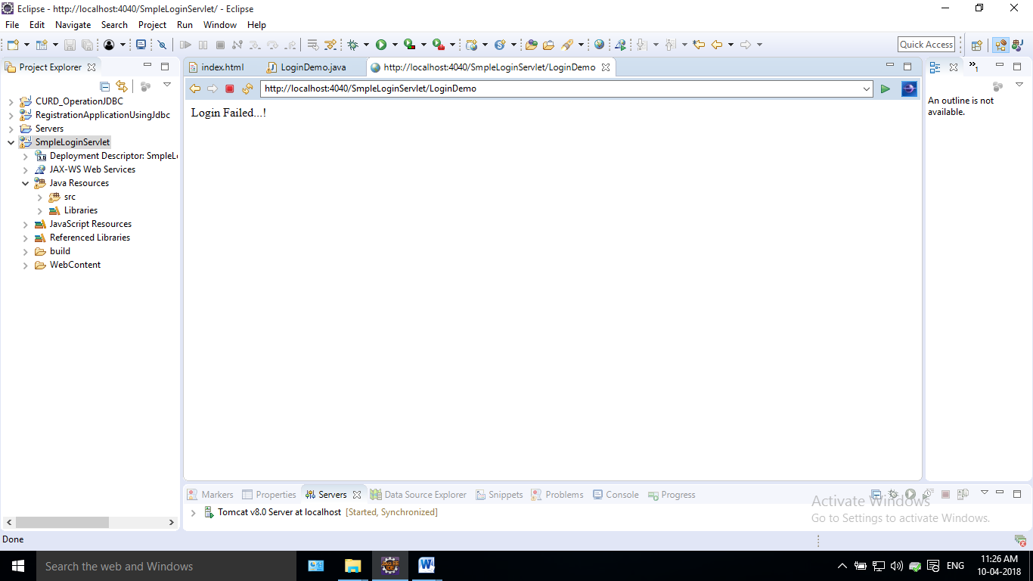

B] WAP for uploading and downloading files using servlet

**Index.html**

B] WAP for uploading and downloading files using servlet

**Index.html**

<!DOCTYPE html>

<html>

<head>

<meta charset=*"ISO-8859-1"*>

<title>download</title>

</head>

<body>

<a href=*"servlet/DownloadDemo"*>download the file</a>

</body>

</html>

**DownloadDemo.java**

**import**java.io.IOException;

**import**java.io.PrintWriter;

**import**javax.servlet.ServletException;

**import**javax.servlet.annotation.WebServlet;

**import**javax.servlet.http.HttpServlet;

**import**javax.servlet.http.HttpServletRequest;

**import**javax.servlet.http.HttpServletResponse;

**publicclass**DownloadDemo**extends**HttpServlet {

**privatestaticfinallong*serialVersionUID*** = 1L;

/**

* **@see**HttpServlet#HttpServlet()

*/

**protectedvoid**doGet(HttpServletRequest request, HttpServletResponse response) **throws**ServletException, IOException {

// **TODO** Auto-generated method stub

response.setContentType("text/html");

PrintWriter out = response.getWriter();

String filename = "home.html";

String filepath = "d://";

response.setContentType("APPLICATION/OCTET-STREAM");

response.setHeader("Content-Disposition","attachment; filename=\"" + filename + "\"");

java.io.FileInputStreamfileInputStream = **new**java.io.FileInputStream(filepath + filename);

**int** i;

**while** ((i=fileInputStream.read()) != -1) {

out.write(i);

}

fileInputStream.close();

out.close();

}

}

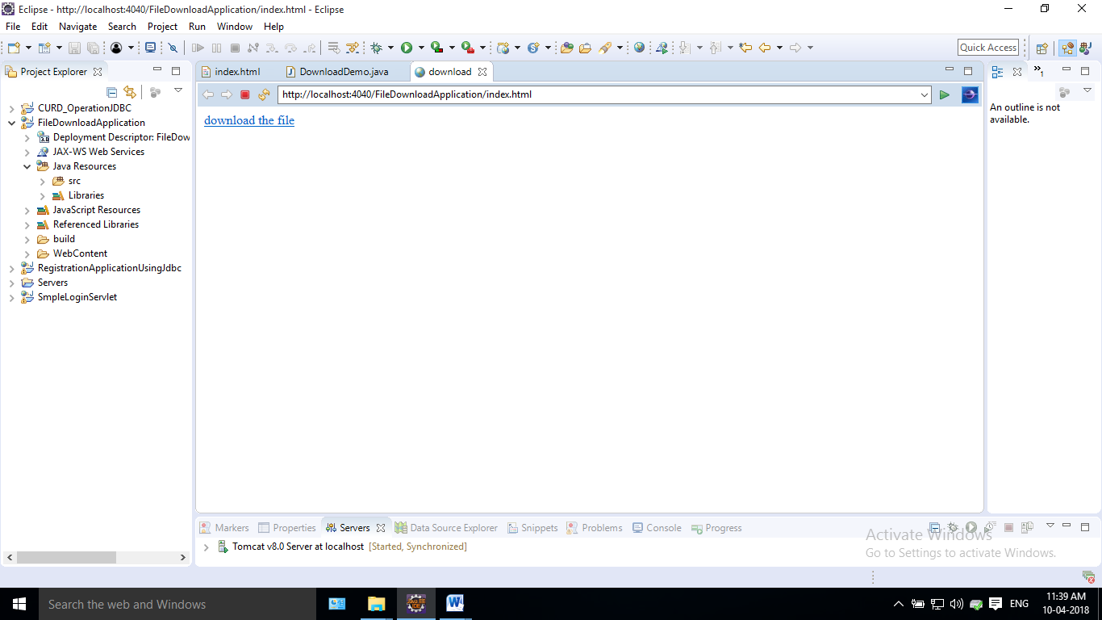

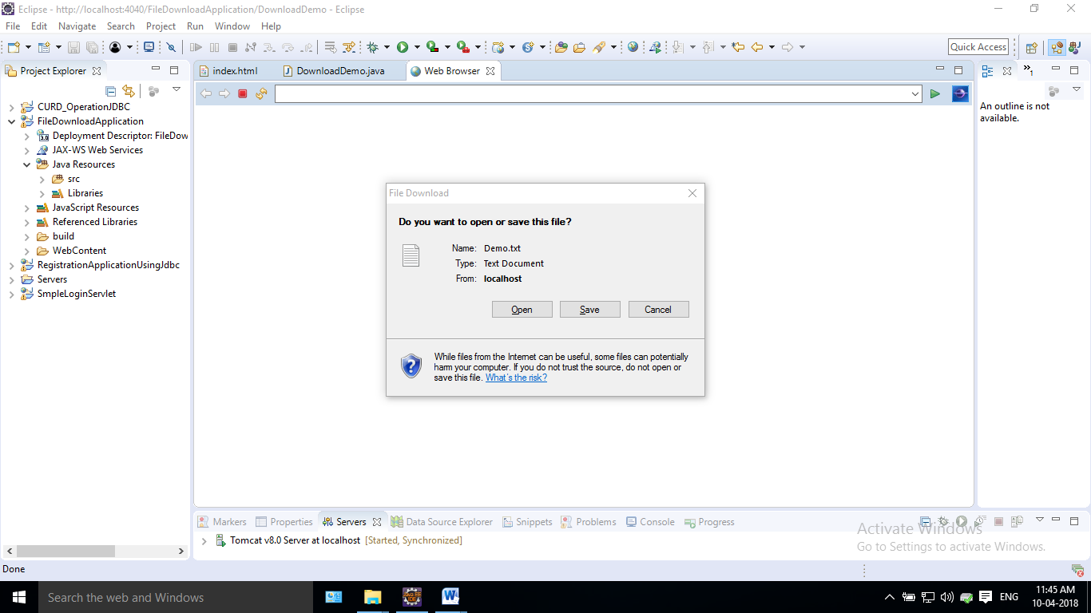

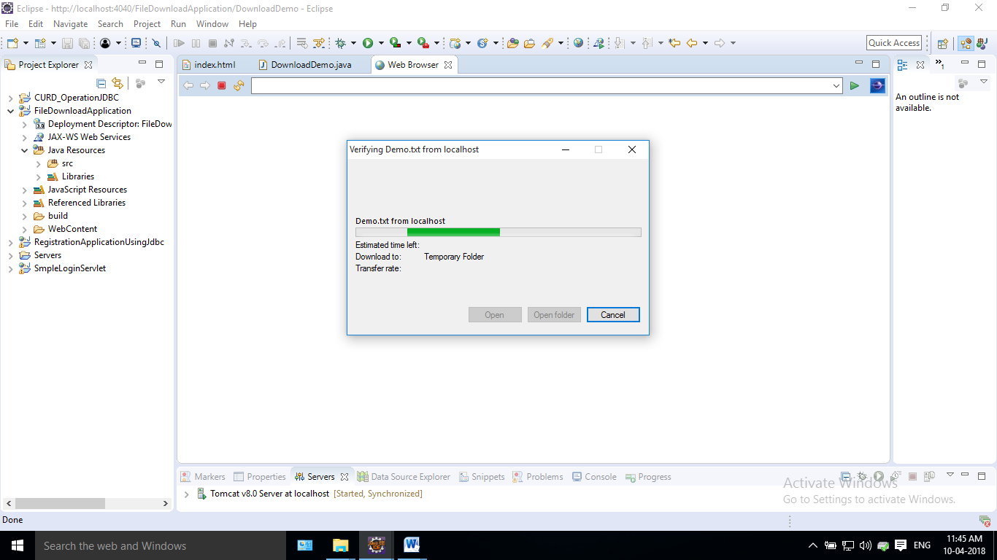

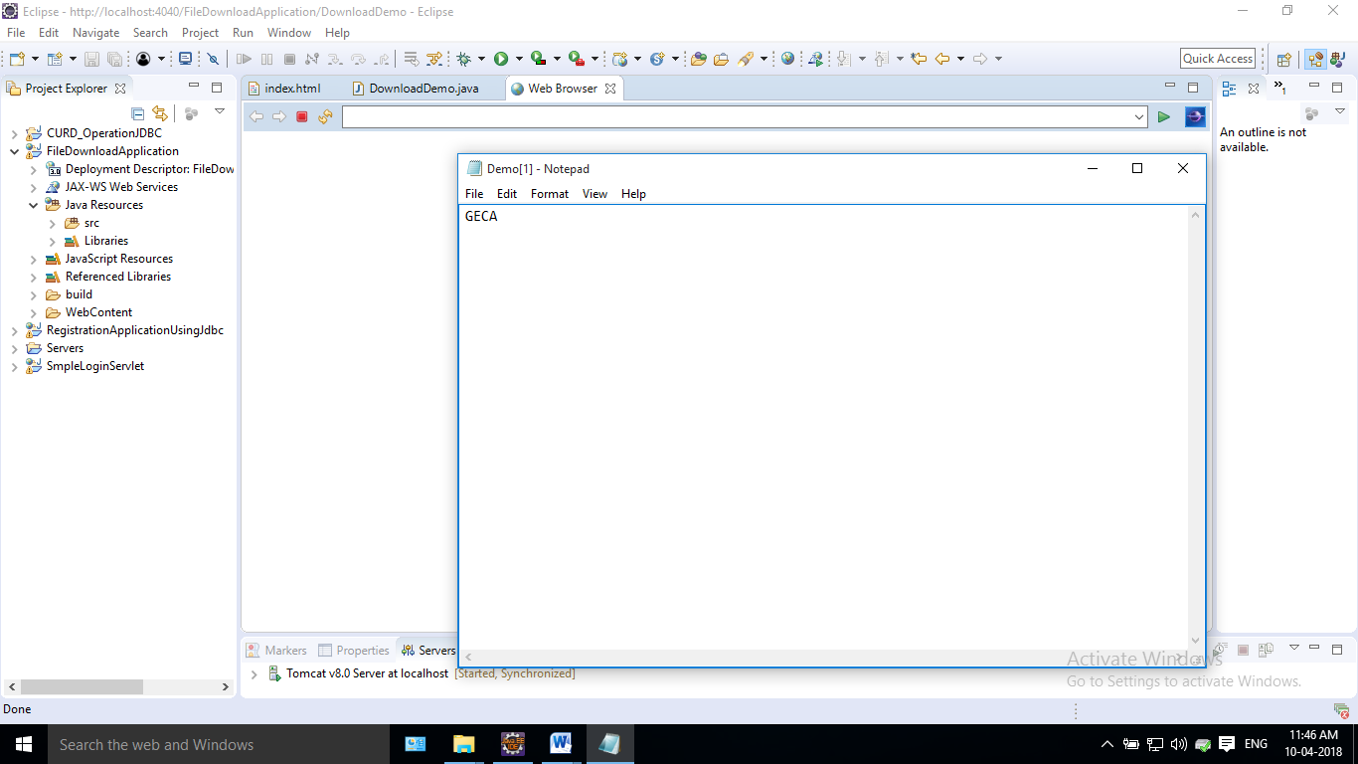**Upload**

**fileupload.html**

<!DOCTYPE html>

<html>

<head>

<meta charset=*"ISO-8859-1"*>

<title>Insert title here</title>

</head>

<body>

<form method=*"post"* action=*"upload"*enctype=*"multipart/form-data"*>

Choose a file : <input type=*"file"* name=*"file"*>

<input type=*"submit"* value=*"upload"*>

</form>

</body>

</html>

**result.jsp**

<%@ page language=*"java"*contentType=*"text/html; charset=ISO-8859-1"*

pageEncoding=*"ISO-8859-1"*%>

<html>

<head>

<meta http-equiv=*"Content-Type"* content=*"text/html"*>

<title>Insert title here</title>

</head>

<body>

<div id=*"result"*>

<h3>${requestScope["message"]}</h3><br>

</div>

File name : ${requestScope["name"]} <br>

File size : ${requestScope["size"]} <br>

File type : ${requestScope["type"]}

</body>

</html>

**UploadServlet.java**

packagecom.servlet.upload;

importjava.io.File;

importjava.io.IOException;

importjava.util.List;

importjavax.servlet.ServletException;

importjavax.servlet.http.HttpServlet;

importjavax.servlet.http.HttpServletRequest;

importjavax.servlet.http.HttpServletResponse;

importorg.apache.commons.fileupload.FileItem;

importorg.apache.commons.fileupload.disk.DiskFileItemFactory;

importorg.apache.commons.fileupload.servlet.ServletFileUpload;

public class UploadServlet extends HttpServlet {

private static final long serialVersionUID = 1L;

private final String UPLOAD_DIRECTORY = "d://uploads";

protected void doPost(HttpServletRequest request, HttpServletResponse response) throws ServletException, IOException {

if(ServletFileUpload.isMultipartContent(request)){

try {

String fname = null;

String fsize = null;

String ftype = null;

List<FileItem>multiparts = new ServletFileUpload(new DiskFileItemFactory()).parseRequest(request);

for(FileItem item : multiparts){

if(!item.isFormField()){

fname = new File(item.getName()).getName();

fsize = new Long(item.getSize()).toString();

ftype = item.getContentType();

item.write( new File(UPLOAD_DIRECTORY + File.separator + fname));

}

}

//File uploaded successfully

request.setAttribute("message", "File Uploaded Successfully");

request.setAttribute("name", fname);

request.setAttribute("size", fsize);

request.setAttribute("type", ftype);

} catch (Exception ex) {

request.setAttribute("message", "File Upload Failed due to " + ex);

}

}else{

request.setAttribute("message","Sorry this Servlet only handles file upload request");

}

request.getRequestDispatcher("/result.jsp").forward(request, response);

}

}

**OUTPUT** :

